Saskatchewan Public Safety Agency

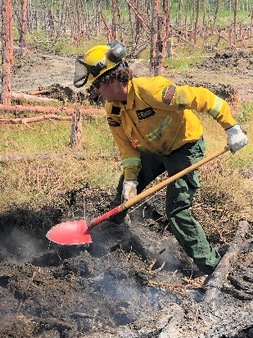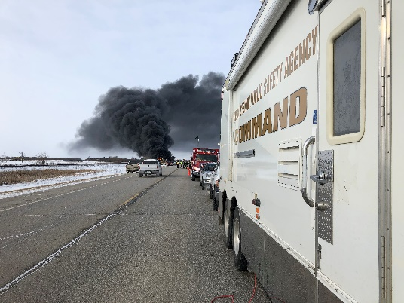



Developing an Emergency Response Plan – A Step by Step Guide



***saskatchewan.ca/spsa***

Table of Contents

Purpose 2

Introduction 2

Why have a plan? 2

How does planning help? 2

Small communities 2

Typical Saskatchewan Emergencies: 2

Authority 2

Step 1 – AUTHORIZE 2

Authorize Plan Development and Establish Your Emergency Management Organization (EMO) 2

Step 2 – APPOINT 2

Step 3 – STRUCTURE 2

Management and Control Structure 2

Step 4 – IDENTIFY AND ANALYZE 2

Identify hazards and analyze risks 2

Step 5 – Emergency Response Plan Development (SPSA Template) 2

Step 6 – Emergency Operation Center Staff Selection and Training 2

Step 7 – Authorization and Publishing 2

Step 8 – Full Scale Exercises and outside Training 2

Companion Documents: 2

# Purpose

The manual is intended to be used by local Emergency Coordinators and Emergency Management Organizations (EMOs) to facilitate Emergency Plan development and the enhancement of a public safety program in their communities and regions.

This manual outlines the legislative authority for the local authority and for the province. First nations are not subject to this legislation but the authorities outlined are similar to those of a chief and council. The manual will also serve to advise communities of SPSA programs and services available to support of emergency management in Saskatchewan.

This manual will serve to guide communities through a step-by-step process that will allow them to develop and implement an Emergency Plan for their community. Each community that successfully implements an emergency plan contributes to the overall preparedness and resiliency of the province.

An effective plan must be kept up to date and exercised annually so the plan is relevant, up to date and most importantly so the persons responsible are prepared to carry out their duties.

The partnership of provincial, municipal and First Nations communities is the cornerstone of an effective emergency management plan and public safety program.

# Introduction

## Why have a plan?

The reason for an emergency plan is simply that it saves lives and saves money. The aim of an emergency plan is to reduce the risk to life and health the residents may face and to reduce the damage to property that often results from an emergency. It does this by allowing elected officials and other agencies in the community to prepare calmly and realistically for likely emergencies. It also helps to locate the resources and the equipment that will be needed, to inform their citizens of the dangers and the ways to avoid them and to quickly arrange help when help is needed. It is far easier to do all this before an emergency strikes rather than during the confusion that normally accompanies unforeseen and disastrous events.

The need to prepare for an emergency is closely connected to the perception of risk. It is not just the perception that a risk exists, but that it involves real and personal danger, that it has a fairly high probability of happening and that it is imminent - it could occur tomorrow, rather than some time in the future.

For example, if your community straddles a major highway or rail line where hazardous materials are regularly transported, your residents probably believe there is a reasonable likelihood of a serious spill, and with good reason. If your community is built on a flood plain, you can reasonably expect to face high water. Any prudent official should be prepared for those contingencies.

Proper planning can reduce the long-term effects of both “human caused” and “natural” disasters and help your community recover faster. It will also help you avoid the mistakes that are often made when an emergency strikes.

## How does planning help?

Emergency planning helps local authorities anticipate problems and possible solutions. You will not be able to anticipate every emergency; however, you will be able to develop appropriate responses for a wide range of occurrences. Those responses will enable your community to react faster and more effectively, especially during the critical early hours of an emergency. Simply knowing who should go where and who does what, will help save lives and property, reduce damage and speed your community's recovery.

## Small communities

Many smaller municipalities and communities act as though the risk of an emergency actually occurring is so remote that it is pointless to plan. A more realistic view is that smaller municipalities are more at risk from an emergency, simply, because they have fewer resources to utilize and because their emergency services are likely to have less experience in dealing with unexpected events than similar services in big cities. Emergencies can occur in any community, of any size and the SPSA promotes a regionalization approach to municipalities to enhance their ability to respond and support the incident or event.

## Typical Saskatchewan Emergencies:

Natural:

* Severe Weather (wind storms, tornadoes, hail, heavy rain, blizzards)
* Floods
* Wildfires fires (grass fires, wildland and forest fires)

Human-caused:

* Infrastructure failure, (transportation corridors, bridges, municipal infrastructure, information technologies)
* Power and energy failures
* Transportation incidents (road, rail, water or air) *
* Structural fires
* Health pandemics
* Chemical, biological, radiological and nuclear accidents
* Acts of terrorism
* Civil unrest or insurrection
* Cyber attacks

*Mass casualty

# Authority

In Saskatchewan, municipalities are obligated to establish emergency plans by *The Emergency Planning Act, 1989,* which also empowers council to be responsible for the direction and control of a municipal emergency response (to take action to implement the plan and to protect the property, health, safety and welfare of the public).

**The legislation is mandatory** - it requires municipalities to:

* Appoint a municipal planning committee
* Establish an Emergency Measures (Management) Organization (EMO)
* Appoint an Emergency Coordinator; and
* Prepare an emergency plan.

Only council or a member of council in the absence of a quorum (it is recommended it be head of council, or acting head) can officially declare a local emergency in a municipality and exercise the special powers the legislation confers on council. The Act protects municipal officials from personal liability for their decisions and actions, provided they are acting in good faith and are not grossly negligent.

The Government of Saskatchewan can also declare an emergency (by an Order in Council) and direct municipal resources, or direct one municipality to assist another during the emergency. The legislation also provides for recovering the extraordinary costs of responding to certain emergencies. A copy of *The Emergency Planning Act, 1989* should be attached to a municipal emergency plan. (see attachments)

# Step 1 – AUTHORIZE

## Authorize Plan Development and Establish Your Emergency Management Organization (EMO)

In a bylaw, refer to *The Emergency Planning Act, 1989* and the requirement/authorization for the development of the Municipal Emergency Plan and the establishment of an Emergency Management Organization (EMO).

First Nations Chiefs and Band Councils will establish Band Council Resolutions to authorize emergency planning within their communities.

Sample bylaws are attached. A fillable PDF Band Council Resolution is found at <https://www.sac-isc.gc.ca/eng/1592232608805/1592234588002#sec5>

# Step 2 – APPOINT

***Appoint an Emergency Coordinator and an Emergency Management***

***Organization (EMO) Committee***

Council should appoint the Emergency Coordinator (and Deputy/Alternate Coordinator) and members to the EMO Committee by resolution.

“Who should be the EMO Coordinator for our municipality?” is a question that is frequently asked. Many smaller communities look to interested volunteers or municipal employees to fill this position. Some municipalities rely on their fire chief, police officers, emergency medical services personnel, elected officials or administrators as these persons are generally knowledgeable, capable and interested. When an emergency happens, however, they would likely be required at the emergency site or have other key roles in the EOC. That will not allow them to perform many of the other roles that the Emergency Coordinator would have in the emergency plan.

Consideration should be given to not asking too much of a fire chief, police officer, emergency medical personnel and others that would have other primary responsibilities during an emergency. For a small town, village, RM, or First Nation it is generally recommended to appoint capable, interested volunteers as Emergency Coordinator and Deputy Emergency Coordinator.

Knowing the typical duties and responsibilities often help in confirming who may be the appropriate appointment:

* Acts as Chairman of the Emergency Management Planning Committee established under the municipal bylaw;
* Stimulates and coordinates the development and maintenance of an emergency plan for the community in co-operation with the departments and agencies of the municipality;
* Submits regular reports to the Emergency Management Control Group to keep them fully informed of progress;
* Correlates all activities of those person and/or organizations involved within the Municipality and designated for the Emergency Management Organization;
* Ensures that a continuous program of training for local Emergency Management Organization personnel is carried out, either by local training classes or attendance at training schools;
* Cooperates with Mutual Aid Area and Saskatchewan Public Safety Agency on all matters pertaining to planning and operations;
* Submits a projected budget to cover costs of emergency management operations within the municipality;
* Acts as advisor to the Municipality during emergencies, events or disasters.
* Ensure the Emergency Response Plan is current and reviewed annually.
* Prepare and maintain annually – EOC “Hasty Kits.” Kits to include current Emergency Plan, maps, relevant SOP documents, pad board material, log sheets, pens, paper, etc. complete with inventory list.
* Open the master event record and ensure that it is maintained for the duration of the emergency.
* Provide technical assistance about the Emergency Plan, its procedures and resources.
* Keep the Municipal Administrator; Mayor/Reeve and Council informed of developments, as they occur. Once EOC is open this becomes the responsibility of the EOC director
* Maintain a record of all action taken.

The committee should have two components – the Executive Group (usually head of council and any other elected official(s), plus the emergency planning committee (more of a working group). The emergency planning committee could include a representative(s) from if possible:

* + Administration (the municipal or band administrator)
  + Police (RCMP, municipal service or First Nations police service)
  + Fire (chief or deputy chief of whichever fire department provides fire service)
  + Regional Health Authority (emergency medical service, public health, hospital authorities)
  + Public works (maintenance personnel or engineering department)
  + Emergency social services (the coordinator of local volunteers to provide food, shelter, etc. to evacuees and emergency workers)
  + Public information/media relations
  + Animal management (veterinarian)
  + Representation from schools or local school boards
  + Transportation
  + Telecommunications
  + Other groups or agencies as required (key businesses, volunteer groups, etc.)

# Step 3 – STRUCTURE

## Management and Control Structure

What is an Emergency Management Organization (EMO)? Basically, it is an organizational structure for emergency response. What should your EMO look like and what are its components? Every EMO should have the following basic components:

1. Executive component – the Local Authority (mayor/reeve/chief and council)
2. Emergency Operations Control Team – this structure has its roots in the Incident Command System (ICS) and training in in ICS is available from the SPSA at no cost.

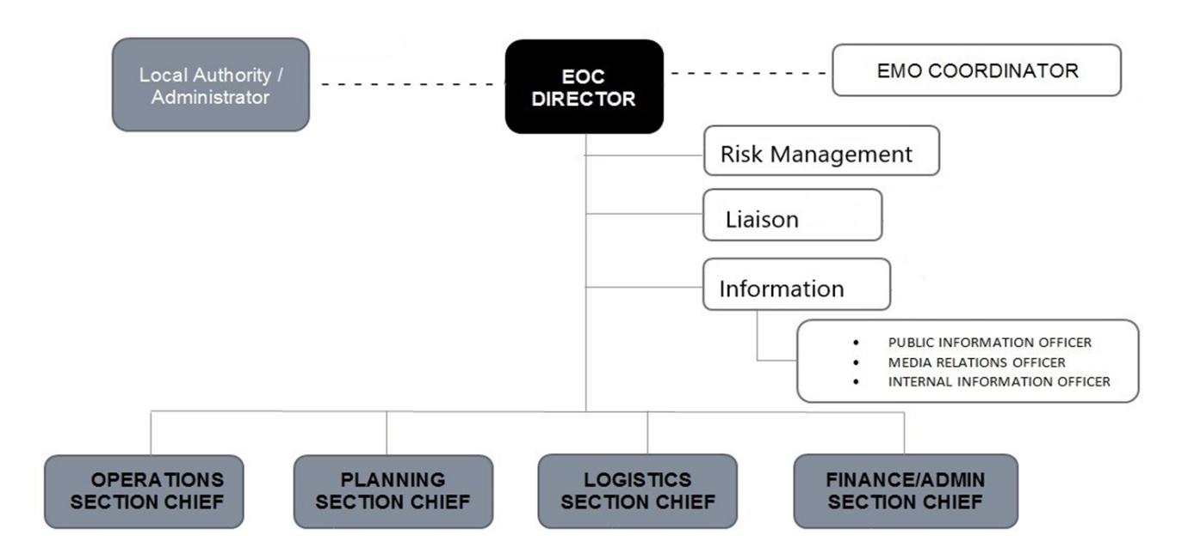

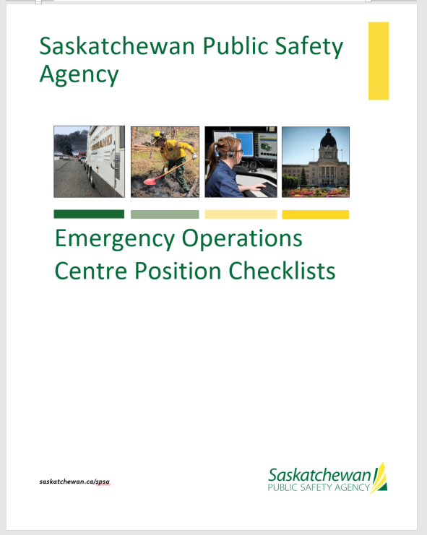

***EMERGENCY OPERATIONS CENTRE POSITION CHECKLISTS***

This Section provides checklists for EOC Functions, Branches and Units required to staff the EOC.

**It is important to note that not all positions are required for all emergencies and in some cases; one person may carry out the responsibilities of more than one position.** Only those functions / positions that are needed to effectively handle the emergency should be staffed.

Position Checklists have been proven to be an effective tool during emergencies. They help guide staff who may not be familiar or practiced in their EOC role and provide useful reminders of items that should be done during an emergency. It is important that the entire Checklist be read through once before initiating action items.

As emergencies and exercises are reviewed, the applicability of the Checklists will be reviewed and revised as needed. The responsibility for this review lies with the EOC Director and the Emergency Measures Organization Coordinator for the jurisdiction.

Step 4 – IDENTIFY AND ANALYZE

## Identify hazards and analyze risks

A hazard is a potential or existing condition that may cause harm to people or damage to property and the environment. Hazard Analysis is the identification of hazards and the impact of their effects on the community.

There are a number of relatively common Saskatchewan hazards; identify and prioritize the potential hazards in your community. While your Emergency Response Plan will be an “All Hazard Response Plan”. Remember, you are not planning for the emergency itself. You are planning to respond to the impact of the emergency. To assist you with this SPSA has a “Hazard Vulnerability Risk Analysis Tool Kit” for municipalities to use to evaluate the risk and mitigate if possible.

The Hazard Vulnerability Risk Analysis Tool Kit is included in the attachments.

# Step 5 – Emergency Response Plan Development (SPSA Template)

While the Emergency Planning Act does not stipulate what your Emergency Response Plan must look like or include and there are numerous plans in circulation, the SPSA has an Emergency Response Plan Template available to municipalities at no cost The sample template has been included as companion document to this manual.

Emergency Services Officers are available to assist your community through the process from bylaws development and mutual aid agreements through training and exercising your plan.

The complete SPSA template has six sections:

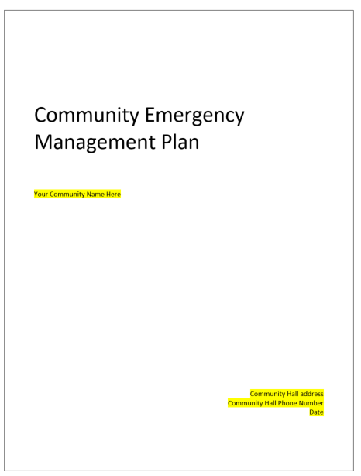

1. The Community section will be published by the municipality and shared with community members, it will inform them of:
   1. The planning process
   2. The methods the municipality may take to respond to emergency events
   3. And provide individuals, families, or businesses a guideline on preparedness such as 72-hour readiness or home fire escape plans
   4. As well as key locations such as emergency reception centers locations in the municipality

This section can also be adapted and used to promote Emergency Preparedness Week and Fire Prevention Week within your community.

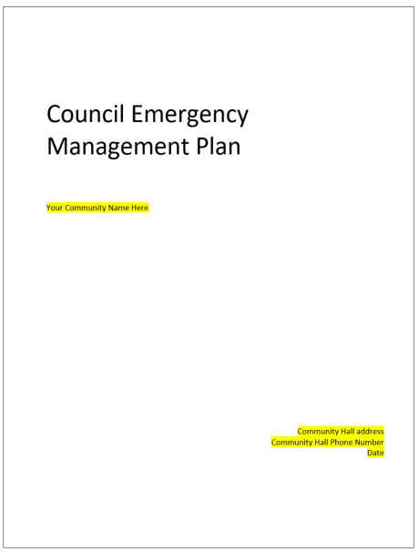

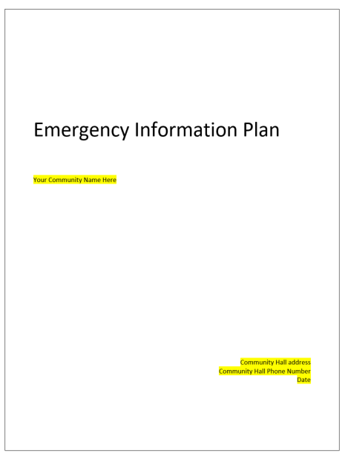

1. Council or Elected Officials section:

* A plan specifically developed for Elected Officials.
* Describes Elected Official roles and responsibilities
* Provides overall emergency policy and direction to the EOC Director.
* Sets expenditure limits.
* Authorizes declaration and termination of the “Local Emergency.”

Acts as a spokesperson for the jurisdiction.

* How to declare a local emergency.
* Background information on emergency management and Emergency Operations Centers in general.

1. Emergency Information and Communication section:

* Outline how information will be shared, which includes public notification and media releases.
* Assign an Information Officer – this plan will assist that role.

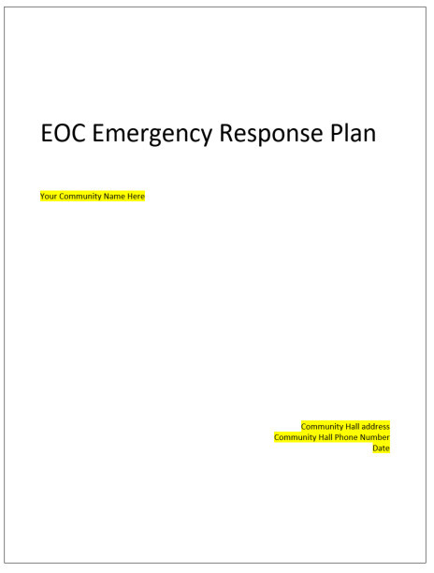

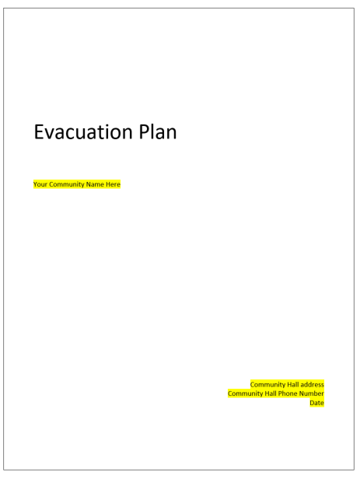

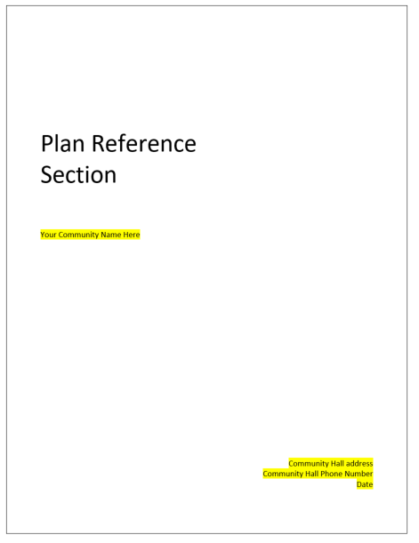

1. The Emergency Operations Centre section:

* For the EMO coordinator and EOC team.
* Describes the roles and responsibilities of team members.
* Outlines the set-up of the EOC facility once activated.
* For in-depth personnel roles and responsibilities, refer to the *Positions Checklist and Aids* document included in the reference section of the plan.

1. The Evacuation section:

* Provides specific methodology for evacuating part or all of your community.
* An ESO will assist you in developing a community specific plan.

1. The Plan Reference section:

* This section will provide users with a list of assets such as:
  + Personnel contact numbers
  + Equipment lists
* Facility locations
* If you are in a regional group, duplicate contact names and numbers are only documented once.

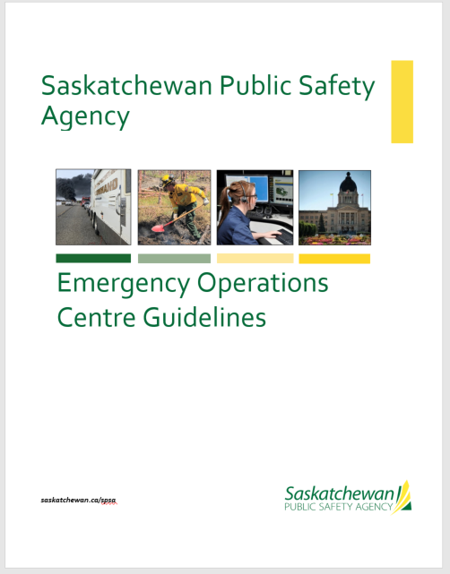

Along with the reference section is the supporting documentation:

This document guides the management, organization, responsibilities, and coordination necessary to provide effective response and recovery.

This document does not address the tactical needs at the emergency site as those are managed at site.

These guidelines are utilized when activation of an EOC is identified and includes aids to assist in the facilitation of situational awareness, documentation and general organization of your support efforts.

Included also to aid your EOC setup will are:

* Agenda and briefing lists
* Document lists
* Situational display sheets
* Forms
* Applicable Government Acts
* Position Checklists
* EOC posters
* Other EOC signage

# Step 6 – Emergency Operation Center Staff Selection and Training

An effective emergency plan is dependent on having a dedicated group of local residents. Without people, the plan will NOT work.

While some municipalities are large enough with sufficient employees to staff their EOC not everyone is that fortunate and creative methods must be used to find individuals with the required skill set willing to participate in your EOC. This is often easier the larger the population area you have to draw from and the SPSA encourages municipalities to enter into mutually beneficial agreements to share both human and physical resources.

The position checklist will assist in identifying individuals that fit the positions best - Operations (doers), Logistics (getters), Planning (thinkers), Finance (payers) as well as a EOC director (knows it all). It may be difficult to find one person for every position but it is recommended to have at least two.

Once EOC team members are in place, the EMO coordinator can arrange for training for them, this will include:

* ICS level 100 to 300
* EOC
* Table top Exercises

# Step 7 – Authorization and Publishing

When the plan is completed, the Local Authority (mayor/reeve/chief and council) will need to approve and authorize it to be published.

Publish the approved plan to your community web page or other community social media sites is a good place to start. Promote individual preparedness and engage your community in events that strengthen your community resiliency.

# Step 8 – Full Scale Exercises and outside Training

While deployment and table top exercises work well, a large scale exercise where incident responders can be involved, will best prepare your community for an emergency situation that may be occur tomorrow.

There are also outside agencies that offer exercises specific to their response (railways, airports as well as other cities in Saskatchewan). These are great opportunities for a community to gain knowledge that can be applied in the future.

# Companion Documents:

Please contact you regional Emergency Services Officer (ESO) once you are ready to begin developing your plan. The ESO can provide guidance and valuable expertise to right size your plan for your community and region.

To find your regional ESO please call 1-800-667-9660 or visit the SPSA website at:

[Saskatchewan Public Safety Agency (SPSA) | Crown Corporations of Saskatchewan | Government of Saskatchewan](https://www.saskatchewan.ca/government/government-structure/crown-corporations/saskatchewan-public-safety-agency)

Your ESO can provide you with the following:

* Sample Bylaw
* Regional Planning Agreement
* Sample Emergency Plan Template
* Hazard Vulnerability Risk Analysis Tool Kit

A copy of Applicable Acts can be found at:

[Emergency Management | Saskatchewan Environment, Public Health and Safety | Government of Saskatchewan](https://www.saskatchewan.ca/residents/environment-public-health-and-safety/emergency-management)