Emergency Operations Centre Emergency Response Plan

Your Community Name Here

Community Hall address

Community Hall Phone Number

Date

Table of Contents

**City/Town/Rural Municipality of “Your Community name here” Emergency Plan** 3

INTRODUCTION & APPROVAL 4

COMMUNITY PROFILE 5

AIM 6

EXCEPTION 6

AUTHORITY 6

EMERGENCY DEFINITION 6

BYLAW 7

Emergency Information Flow Chart 8

Emergency Management Organization (EMO) Coordinator Responsibilities 9

Emergency Operations Centres 9

Titles 9

General Staff 10

Management Staff 10

Management Team 10

EOC Structure 10

Authority to Activate the EOC 10

Declaration Not Required 11

Activation Criteria 11

Termination 11

EOC Activation Levels 11

Response Goals 12

Roles and Responsibilities of EOC Team Members 15

EOC Director 15

Responsibilities: 15

Liaison Officer 15

Responsibilities: 15

Risk Management Officer 16

Responsibilities: 16

Information Officer 16

Responsibilities: 16

Operations Section Chief 17

Responsibilities: 17

Planning Section Chief 18

Responsibilities: 18

Logistics Section Chief 18

Responsibilities: 18

Responsibilities: 19

EOC Planning Processes 20

Meetings 21

Objectives and Strategies Meeting 21

Planning Meeting 21

EOC Briefing/Meeting 21

EOC Key Documentation 21

Position Logs (EOC 414) 21

Incident Reports (ICS 201, EOC 550) 21

Status Reports (EOC 401) 21

EOC Action Plans (EOC 502) 22

EOC Situation Reports (EOC 501) 22

Resource Requests (EOC 514) 22

Media Contact Tracking (EOC 423/424) 22

Expenditure Tracking 23

**City/Town/Rural Municipality of “Your Community name here” Emergency Plan**

The City/Town/Rural Municipality of “Your Community name here”has an emergency plan that coordinate the community’s response to any major event or emergency.

There are **six main components to the plan**. These are:

* **The Public Emergency Management Plan** – It describes the methodology and general process that the municipality will uses to respond to emergency events as well as the bylaw that established the planning process, but contains no confidential information. This section also contains information that individuals can use to create a personal/family/business plan to assist in emergency situations.
* **Council Emergency Plan** – This plan is specific for Municipal Mayors/Reeves and Councilors. It describes their roles and responsibilities, how to declare a local emergency and provides background information on emergency management in general.
* **Emergency Response Plan** – This plan is for the Emergency Management Organization Coordinator and the Emergency Operations Centre Team members. It describes roles and responsibilities of the Emergency Operations Centre Team members as well as outlining how to establish and operate the Emergency Operation Centre.
* **Emergency Information Plan** – This is the crisis communications plan.  It outlines the how information will be shared, including public notification and media releases.
* **Evacuation Plan** – This plan is for emergency services staff who are in tactical command of an incident site(s). Their tactical operations achieve the goals and priorities of the Emergency Operations Centre and Council. This plan provides direction for escalating events from day-to-day emergencies to fully supported major disasters.
* **Plan reference section** – containing contact list information for people and resources as well as forms and other emergency operations centre documentation.

# INTRODUCTION & APPROVAL

The contents, of this Emergency Response Plan, provide guidance for *“your community name here”* to respond effectively to an incident or major emergency.

This document will not prevent nor reduce the possibility of an incident or emergency occurring. It will aid in providing a prompt and coordinated multi-agency response, thereby reducing human suffering and loss or damage to property or the environment.

For this plan to be effective, it is important that all concerned are made aware of its provisions and that every official, agency and department be prepared to carry out their assigned functions and responsibilities in an emergency.

The public must be informed about the Emergency Plan and educated as to certain elements (i.e., Warning and Evacuation Procedures).

The Emergency Response Plan is a living document that will be amended as necessary.

_______________________________________ ________________

Date

Joe Smith – Mayor/Reeve – Community name

# COMMUNITY PROFILE

“your community’s information here - include your map/maps”

# AIM

The aim of this plan is to provide a mechanism to handle any major emergency that threatens the health, safety and welfare of the citizens, or the environment, or property within the “your community name here”.

# 

# EXCEPTION

This Emergency Response Plan does not apply to those day-to-day situations which can be handled by the responsible municipal service(s) on its (their) own.

# AUTHORITY

This Emergency Response Plan is authorized in accordance with:

* Bylaw No XX-XXX
* *The Emergency Planning Act, 1989* - Chapter 8 E-8.1 of the Statutes of Saskatchewan

# EMERGENCY DEFINITION

An emergency is defined as any abnormal or unique event which occurs with some degree of surprise to demand unusual, extensive and demanding response effort, however caused, which has resulted in or may result in:

* the loss of life; or
* serious harm or damage to the safety, health or welfare of people; or
* widespread damage to property or the environment.

A major emergency is a further escalation with the potential to exceed the community’s emergency response capabilities. A major emergency will require resources from other communities and the province.

The most likely major emergencies that could occur within the *“your community name here”* are:

* Fire (Structural/Forest/Grass)
* Dangerous Goods or Hazardous Materials release
* Epidemic/Pandemic or Health (Contaminated Water or Air Quality)
* Extended Utility Outage (Power, Natural Gas, water)
* Public Infrastructure Failure (transportation routes, sanitary septic, etc)
* Severe Weather (Blizzard, Wind Storm, Tornado, Hail)
* Mass Transit Incident (Road, Rail)
* Major Aircraft Crash
* Flood
* Pipeline Leak/ Explosion
* Terrorism (Bomb, Shooting)
* Lost Person (Search and Rescue)

# BYLAW

“*Insert your communities Emergency Management By-law here”*

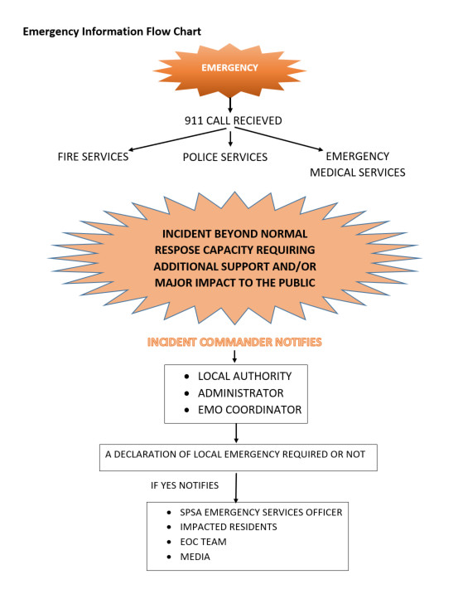

## Emergency Information Flow Chart

# 

# Emergency Management Organization (EMO) Coordinator Responsibilities

* Ensuring that the Emergency Operation Centre (EOC) is ready for use on short notice
* Prepare and maintain annually – EOC Kits (hasty kits).
* Co-ordinate all EOC activities, including the scheduling of regular meetings training and training exercises.
* Ensure the Emergency Management/Response Plan is current and reviewed annually.
* Activate the emergency notification system through the fan-out list.
* Open the master event record and ensure that it is maintained for the duration of the emergency.
* Provide technical assistance about the Emergency Management/Response Plan, its procedures and resources.
* Ensure all directions from the Mayor/Reeve and Council are carried out.
* Maintain a record of all action taken.

# Emergency Operations Centres

Emergency Operations Centres (EOC) are normally activated at the request of the Incident Commander or senior municipal officials to provide overall jurisdictional direction and control, coordination and resource support. It is recommended that an EOC utilize the Incident Command System principles for organizing and managing EOC operations and activities. By using ICS five functional elements an EOC will operate more effectively and consistently with its regional and provincial counterparts.

An EOC normally turns to the DOC (District Operations Centre) / PEOC for support when all of their resources are exhausted or they require coordination that is outside of their jurisdiction.

## Titles

The supervisor of each organizational element in the EOC has the following title:

* EOC Director
* Section Chief
* Branch Director
* Group Supervisor
* Unit Leaders

## General Staff

The Operations, Planning, Logistics and Finance / Administration Section Chiefs constitute the EOC General Staff. The General Staff are responsible for:

* Overseeing the internal functioning of their section, and
* Interacting with each other, the EOC Director, and other entities within the EOC to ensure the effective functioning of the EOC organization.

## Management Staff

The EOC Director may appoint persons to fill the EOC Management staff positions of Information Officer, Liaison Officer and Risk Management Officer.

## Management Team

The EOC Director, General Staff and Management Staff function as the EOC Management Team.

## EOC Structure

**It is important to remember that not every EOC function and / or element will be filled in every emergency or disaster.**

The situation at hand will dictate the functions and elements to be activated. As a minimum, an active EOC requires only an EOC Director. Other functions are staffed as needed.

The Local Emergency Measures Coordinator and / or EOC Director are responsible for ensuring that the EOC is ready for use on short notice by establishing a regular maintenance and testing schedule.

The EOC contains information display materials, telecommunications and any additional supporting equipment, documents, and supplies required to ensure efficient operations and effective emergency management. In addition, power generation capabilities and other special life support systems may be required to allow for continuous operations apart from normal public utilities and services.

## Authority to Activate the EOC

An EOC may be activated by any one of the following:

* + An Incident Commander within the EOC’s jurisdiction
  + Persons named in the jurisdictions’ emergency plan such as: City Manager / Administrator, Fire Chief, Police Chief, Mayor or Elected Officials, etc.

## Declaration Not Required

Note: The EOC may be activated with or without a Declaration of a Local Emergency; however, it **must** be activated once a Declaration has been made.

## Activation Criteria

#### Suggested criteria for activating the EOC include:

* + Significant number of people at risk
  + Response coordination required because of:
    - * + Large or widespread event
      * Multiple emergency sites
      * Several responding agencies
  + Resource coordination required because of
    - * + Limited local resources, and
        + Significant need for outside resources
        + Uncertain conditions
        + Possibility of escalation of the event
        + Unknown extent of damage
        + Potential threat to people, property and / or environment
        + Declaration of a Local Emergency is made

## Termination

The Emergency Operations Centre Director will terminate the EOC activity for the current incident and notify all participants. The Director must consider the requirements of termination virtually from the outset. The Demobilization Unit Leader supervises and administers the termination process, staying behind if necessary after the EOC is closed.

Suggested criteria for terminating EOC operations include:

* + Individual EOC functions are no longer required.
  + A Declaration of Local Emergency is lifted.
  + Coordination of response activities and / or resources is no longer required.
  + Event has been contained and emergency personnel have returned to regular duties.

## EOC Activation Levels

There are three levels of potential activation. The term “Event” is used to describe an occurrence based on the jurisdictions pre-identified hazards. An “incident” describes one or more occurrences that happen as the direct result of an event.

The level of EOC activation is determined by the magnitude, scope and stage of the event. **Only those EOC functions and positions that are required to meet current response objectives need to be activated. Non-activated functions and positions will be the responsibility of the next highest level in the EOC organization.** Each EOC function must have a person in charge.

The EOC Organizational structure should be flexible enough to expand and contract as needed. EOC staff may be required to take on more than one position (role), as determined by the nature of the emergency event, availability of resources and / or as assigned by a Supervisor.

## Response Goals

The EOC supports a prescribed set of response goals set out in priority as follows:

* Save lives
* Provide for the safety and health of all responders
* Protect public health
* Protect government infrastructure
* Protect property
* Protect the environment
* Reduce economic and social losses.

Action Plans from all levels will take these goals into consideration.

**EOC ACTIVATION LEVELS**

|  |  |  |
| --- | --- | --- |
| **EOC ACTIVATION**  **LEVELS** | **EVENT/SITUATION** | **MINIMUM STAFFING RECOMMENDED** |
| **One** | * Small event * One site * Two or more agencies involved * Potential threat of: * Flood * Severe storm * Interface fire | * EOC Director * Operations Section Chief * SPSA notified |
| **Two** | * Moderate event * Two or more sites * Several agencies involved * Major scheduled event * Limited evacuations * Some resources / support required | * EOC Director * Section Chiefs (as required) * SPSA ESO / SPSA District Operations Centres (DOC) limited activation |
| **Three** | * Major event * Multiple sites * Regional disaster * Multiple agencies involved * Extensive evacuations * Resources / support required | * All EOC functions and positions (as required) * Policy Group * SPSA ESO agency representatives and SPSA District Operations Centres (DOC) activation |

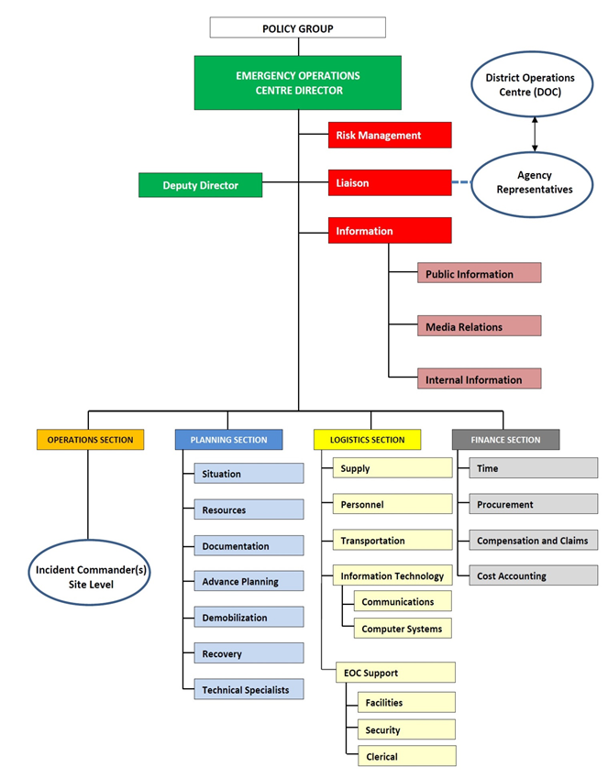

# Roles and Responsibilities of EOC Team Members

EOC team members can and should access training. Training is available through the SPSA. Assignment of individuals prior to an event ensures potential members understand their role and have the opportunity to access training. Note that an individual can be responsible for more than one area and not every event requires all EOC positions to be filled.

When an event occurs, the SPSA can assist in operating your EOC if the community is unable to fully do so.

## EOC Director

“Insert primary and backup name”

### Responsibilities:

* Exercise overall management responsibility for the coordination between emergency response and supporting agencies in the EOC. In conjunction with Incident Commander(s), EOC General Staff and Management Staff, set priorities for support response efforts in the affected area.
* Provide support to local authorities and ensure that all actions are accomplished within the priorities established.
* Establish the appropriate staffing level for the EOC and continuously monitor organizational effectiveness to ensure that appropriate modifications occur as required.
* Ensure that inter-agency coordination is accomplished effectively within the EOC.
* Direct, appropriate emergency public information actions using the best methods of dissemination. Approve the issuance of press releases, and other public information materials as required.
* Liaise with Policy Group and / or Elected Officials.
* Ensure risk management principles and procedures are applied for all EOC activities.

## Liaison Officer

“Insert primary and backup name”

### Responsibilities:

* The Liaison Officer functions as a point of contact for, and interaction with, representatives from other agencies arriving at the EOC.
* Liaise with any DOCs (District Operation Centres) and organizations not represented in the EOC.
* Coordinate agency representatives for the EOC as required to ensure adequate EOC structure, and fill all necessary roles and responsibilities enabling the EOC to function effectively and efficiently.
* Assist and serve as an advisor to the EOC Director and Management Team as needed, providing information and guidance related to the external functions of the EOC.
* Assist the EOC Director in ensuring proper procedures are in place for directing agency representatives, communicating with elected officials, and conducting VIP / visitor tours of the EOC facility.
* Liaise with local authorities other EOCs, Provincial and Federal organizations, communicating EOC guidelines, directives, Action Plans and Situation Information.

## Risk Management Officer

“Insert primary and backup name”

### Responsibilities:

* **Risk Management**– Ensures that good risk management practices are applied throughout the response organization and that every function contributes to the management of risk. Protects the interests of all EOC participants, agencies, and organizations by ensuring due diligence in information collection, decision-making, and implementation. Monitors situations for risk exposures and ascertains probabilities and potential consequences of future events.
* **Safety** – The Safety Officer provides advice on safety issues. The Safety Officer has the authority to halt or modify any and all unsafe operations within or outside the scope of the EOC Action Plan, notifying the EOC Director of actions taken. It should be noted that while the Safety Officer has responsibility for safety, it is recommended that a safety specialist be appointed who is familiar with all aspects of safety and relevant legislation.
* **Security** – The Safety Officer ensures that appropriate security measures have been established to allow for only authorized access to the EOC facility and documentation.

Reports to:

* + EOC Director

## Information Officer

“Insert primary and backup name”

### Responsibilities:

* Serve as the coordination point for all public information, media relations and internal information sources for the EOC.
* Coordinate and supervise all staff assigned as Assistant Information Officers and their activities.

#### Public Information:

* Ensure that the public within the affected area receives complete, accurate, and consistent information about life safety procedures, public health advisories, relief and assistance programs and other vital information.
* Ensure that a hotline or call centre is established for the public to access helpful information and advice. Provide the call takers with timely and accurate messaging sheets so that they offer only confirmed and approved information.

#### Media Relations:

* Serve as the coordination point for all media releases for the EOC.
* Coordinate media releases with officials representing other affected emergency response agencies.
* Develop the format for press conferences and briefings in conjunction with the EOC Director.
* Maintain a positive relationship with the media representatives, monitoring all broadcasts and written articles for accuracy.

#### Internal Information:

* In consultation with EOC Director and Liaison Officer, coordinate VIP and visitor tours of the EOC facility.
* Develop helpful messaging sheets and / or FAQ sheets (frequently asked questions and answers) to ensure consistent and accurate information sharing amongst EOC staff.
* Liaise with the Information Officers at site(s) other EOCs, DOCs, Prov. EOC and other external agencies.

## Operations Section Chief

“Insert primary and backup name”

### Responsibilities:

* Ensure that the Operations Coordination function is carried out including coordination of response for all operational functions assigned to the EOC.
* Ensure that operational objectives and assignments identified in the EOC Action Plan are carried out effectively.
* Establish the appropriate level of Branch and Unit organizations within the Operations Section, continuously monitoring the effectiveness and modifying accordingly.
* Coordinate any activated DOCs in the operational area.
* Maintain a communications link between Incident Commanders (sites), DOCs and the EOC for the purpose of coordinating the overall response, resource requests and event status information.
* Ensure that the Planning Section is provided with Branch Status Reports and Major Incident Reports.
* Conduct periodic Operations briefings for the EOC Director and Management team as required or requested.
* Supervise the Operations Section.

## Planning Section Chief

“Insert primary and backup name”

### Responsibilities:

* Ensures that the following responsibilities of the Planning Section are addressed as required:
  + Collect, analyze, and display situation information
  + Prepare periodic Situation Reports
  + Prepare and distribute EOC Action Plan and facilitate Action Planning process
  + Track Resources
  + Conduct Advance Planning activities and report
  + Document and maintain files on all EOC activities
  + Provide technical support services to the various EOC sections and branches.
* Establishes the appropriate level of organization for the Planning Section.
* Exercises overall responsibility for the coordination of branch / unit activities within the section.
* Keeps the EOC Director informed of significant issues affecting the Planning Section.
* In coordination with the other Section Chiefs, ensures that Status Reports are completed and utilized as a basis for EOC Situation Reports, and EOC Action Plans.

## Logistics Section Chief

“Insert primary and backup name”

### Responsibilities:

* Ensure the Logistics function is carried out in support of the EOC. This function includes providing telecommunication services and information technology, locating or acquiring equipment, supplies, personnel, facilities, and transportation as well as arranging for food, lodging, and other support services as required both for the EOC and site requirements.
* Establish the appropriate level of branch and / or unit staffing within the Logistics Section, continuously monitoring the effectiveness of the organization and modifying as required.
* Ensure section objectives as stated in the EOC Action Plan are accomplished within the operational period or within the estimated time frame.
* Coordinate closely with the Operations Section Chief to establish priorities for resource allocation within the operational area.
* Keep the EOC Director informed of all significant issues relating to the Logistics Section.
* Ensure critical resources are allocated according to EOC Action Plan policy, priorities and direction.
* Coordinate food and lodging for EOC and Site Personnel (if requested).
* Supervise the Logistics Section.

**Finance / Administration Section Chief**

“Insert primary and backup name”

### Responsibilities:

* Ensure that all financial records are maintained throughout the event or disaster.
* Ensure that all on-duty time is recorded and collected for all personnel.
* Ensure there is a continuum of the payroll process for all employees responding to the event or disaster.
* In consultation with EOC Director determine spending limits, if any, for Logistics, Operations, and Management Staff.
* Ensure that workers’ compensation claims, resulting from the response are processed within a reasonable time, given the nature of the situation.
* Ensure that all travel and expense claims are processed within a reasonable time, given the nature of the situation.
* Activate units within the Finance / Administration Section as required; monitor section activities continuously and modify the organization as needed.
* Ensure that all recovery documentation and Disaster Assistance paperwork is accurately maintained and submitted to PDAP.
* Supervise the Finance / Administration Section.

## EOC Planning Processes



## Meetings

### Objectives and Strategies Meeting

**Purpose**: Develop objectives and a unified strategy for accomplishing objectives

**Attendees:** EOC Manager, Section Chiefs, Situation Unit Leader (SUL)

**Facilitator:** Planning Section Chief or designee

### Planning Meeting

**Purpose**: Gather input for the development of the EOC action plan

**Attendees:** EOC Manager, Command staff, Section Chiefs, Situation Unit Leader

**Facilitator:** Planning Section Chief or designee

### EOC Briefing/Meeting

**Purpose**: Review previous/new business, gather situational updates and explain the next operational periods plan priorities

**Attendees:** EOC Manager, Command staff, Section Chiefs, Situation Unit Leader

**Facilitator:** Planning Section Chief or designee

** Meeting Agendas can be found in the appendixes

## EOC Key Documentation

### Position Logs (EOC 414)

* + Used by all functions to record key activities, significant decisions, actions, enquiries
  + Remain with function
  + Number pages and keep complete

### Incident Reports (ICS 201, EOC 550)

* Used by Operations to track incoming incident details and updates, includes:

### Status Reports (EOC 401)

* Used by functions to report on status of activities, includes:
* Current Situation (incidents, actions taken, resource status…)
* Outstanding Issues/Challenges/Problems
* Anticipated Priorities/Activities (for future operational periods)
* Other Comments/Issues (e.g., media information,
* public information bulletins, safety tips…)

### EOC Action Plans (EOC 502)

* + Completed by Planning, input from Management Team
  + Validation required from Management Team and approved by EOC Director
  + Lists Priorities/Objectives - **“What”** the EOC is doing to satisfy the “Standard Response Goals”
  + List Objectives/Priorities in order of importance
  + Further describes Tasks - **“How”** personnel will be addressing the priorities/objectives that are listed
  + Based on upcoming Operational Period

### EOC Situation Reports (EOC 501)

* + Completed by Situation Unit in Planning
  + Used to capture and share situational information
  + Input from many functions required
  + Provides a summary of situational information
  + Usually completed every 12 or 24 hours
  + Commonly shared with higher/lower level EOCs and cooperating/assisting agencies as well as briefing elected officials
  + Limited and authorized distribution only

### Resource Requests (EOC 514)

* + All site requests vetted by EOC Operations
  + Operations fills requests within Operations from other Branches when resources readily available
  + Logistics acquires items not readily available through Operations
  + Requests provided to Logistics with necessary approval
  + Priority/precedence level identified by initiator
  + Requests tracked by Logistics and initiator **(EOC 515)**
  + Critical resources allocated by established priorities

### Media Contact Tracking (EOC 423/424)

* Used by Information Officer to track media inquiries

### Expenditure Tracking

* Municipal expenditure documents, used to track expenditures incurred by support of the incident.

** The complete list of forms, checklists and guidelines can be found in the appendixes.