Community Emergency Management Plan

Your Community Name Here

Community Hall address
Community Hall Phone Number
Date

Table of Contents
The “City/Town/Rural Municipality” of “Your Community name here” Emergency Plan 4
INTRODUCTION & APPROVAL 5
COMMUNITY PROFILE 5
AIM 6
EXCEPTION 6
AUTHORITY 6
EMERGENCY DEFINITION 6
BYLAW 6
7
Emergency Operation Centre 8
Emergency Preparedness 8
Evacuations 8
Evacuation Process 9
Reception Centres 9

The “City/Town/Rural Municipality” of “Your Community name here” Emergency Plan

The City/Town/Rural Municipality of “Your Community name here” has an emergency plan that coordinates the community’s response to any major event or emergency.
There are six main components to the plan. These are:
- The Public Emergency Management Plan – It describes the methodology and general process that the municipality will uses to respond to emergency events as well as the bylaw that established the planning process, but contains no confidential information. This section also contains information that individuals can use to create a personal/family/business plan to assist in emergency situations.

- Council Emergency Plan – This plan is specific for Municipal Mayors/Reeves and Councilors. It describes their roles and responsibilities, how to declare a local emergency and provides background information on emergency management in general.

- Emergency Response Plan – This plan is for the Emergency Management Organization Coordinator and the Emergency Operations Centre Team members. It describes roles and responsibilities of the Emergency Operations Centre Team members as well as outlining how to establish and operate the Emergency Operation Centre.

- Emergency Information Plan – This is the crisis communications plan. It outlines the how information should be shared with internal and external audiences.

- Evacuation Plan – This plan is for emergency services staff who are in tactical command of an incident site(s). Their tactical operations achieve the goals and priorities of the Emergency Operations Centre and Council. This plan provides direction for escalating events from day-to-day emergencies to fully supported major disasters.

- Plan reference section – This section contains contact list information for people and resources as well as forms and other emergency operations centre documentation.

INTRODUCTION & APPROVAL
The contents, of this Emergency Response Plan, provide guidance for “your community name here” to respond effectively to an incident or major emergency.

This document will not prevent the possibility of an incident or emergency occurring. It is intended to provide citizens with information to make them as resilient as possible in times of emergency; this will allow our local authority and first responder to focus on those individuals that are in the most need of assistance. For your local authority and emergency operations centre staff this plan will aid in providing a prompt and coordinated multi-agency response, thereby reducing human suffering and loss or damage to property or the environment.

For this plan to be effective, it is important that all concerned are made aware of its provisions and that every official, agency and department be prepared to carry out their assigned functions and responsibilities in an emergency.

The public must be informed about the Emergency Planning and educated as to certain elements (i.e., Warning and Evacuation Procedures).

The Emergency Response Plan is a living document that will be amended as necessary.

_______________________________________ ________________
Date
Joe Smith – Mayor/Reeve – Community name

COMMUNITY PROFILE
“your community’s information here including map/maps”

AIM

The aim of this plan is to provide a mechanism to handle any major emergency that threatens the health, safety and welfare of the citizens, or the environment, or property within the “your community name here”.

EXCEPTION

This Emergency Response Plan does not apply to those day-to-day situations which can be handled by the responsible municipal service(s) on its (their) own.

AUTHORITY

This Emergency Response Plan is authorized in accordance with:
- Bylaw No XX-XXX
- The Emergency Planning Act, 1989 - Chapter 8 E-8.1 of the Statutes of Saskatchewan

EMERGENCY DEFINITION

An emergency is defined as any abnormal or unique event which occurs with some degree of surprise to demand unusual, extensive and demanding response effort, however caused, which has resulted in or may result in:
- the loss of life; or
- serious harm or damage to the safety, health or welfare of people; or
- widespread damage to property or the environment.

A major emergency is a further escalation with the potential to exceed the community’s emergency response capabilities. A major emergency will require resources from other communities and the province.

The most likely major emergencies that could occur within the “your community name here” are:
- (list the most likely events based on your assessment of local risk)

BYLAW
“Insert your communities Emergency Management By-law here”

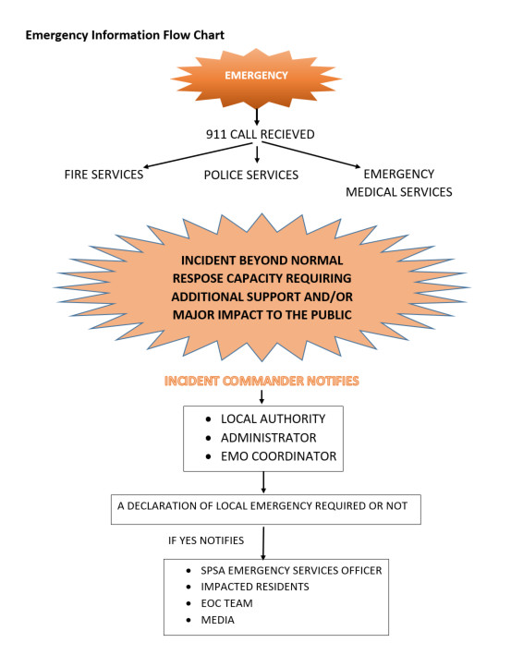

Emergency Operation Centre

The emergency plan enables the activation of an Emergency Operations Centre that will:
- Assist emergency personnel to respond quickly and effectively to potential disasters such as wildland fires, major storms, chemical spills, floods, plane crashes, or tornados.
- Provide a concentrated assessment and decision-making body that can best utilize all available resources, and if necessary, resources from the Province.
- Prioritize recovery goals and objectives.
- Coordination of request for responding, mutual aid and support agencies
- Provide Policy direction to Incident site responders
- Provide communications and public/media information packages for elected officials use.

Emergency Preparedness

Disasters and emergency events have shown the need for individuals to be prepared to look after themselves, their families and pets for a minimum of 72 hours. There are many sources for important information. A fact sheet you can provide to residents can be found at saskatchewan.ca/spsa.

Evacuations

Local Authority Evacuation Orders

Ordering an evacuation of all or part of an emergency area is a very serious step and requires detailed planning. In Saskatchewan, the Emergency Planning Act (1989) permits the head of a local authority to declare a Local Emergency, and that allows the local authority to order an evacuation should it be absolutely necessary. There are several other statutes (Fire Services Act, Wildfire Act and the Public Health Act) that can be used to order an evacuation.

When it is determined that an evacuation is required, the warning must be timely and accurate. While the main concern is the preservation of life, those displaced from their homes or businesses may be experiencing inconvenience, anxiety and fear.

Removing people from their homes and livelihoods must not be taken lightly. People will already be under duress during an emergency; however, public safety must be first. It is a delicate balancing act.

Evacuation Process

Stage 1 - Evacuation Alert
Authorities will alert the population at risk of the potential for evacuation because of the danger of possible loss of life and they should be prepared to evacuate the area. This warning will be transmitted by:
- Door-to-door campaign with pamphlets/letter delivered
- Radio and/or television broadcast
- Sirens and mobile public address announcements
- Telephone calls
- Electronic media (internet/social media)

Note: even at this stage, plans will be in place to move handicapped persons, vacationers, and voluntary evacuees. You should also consider readying extra supplies (clothes, shoes, sleeping bags or blankets, personal items (toiletries), playing cards and games for children) to supplement your emergency kit.

Stage 2 - Evacuation Order
The population at risk is ordered to evacuate the area specified in a formal written order. This is an order and as such does not allow for any discretionary decision on the part of the population at risk. They must leave the area immediately. The police will enforce the Evacuation Order. This order will be transmitted by:
  - Door-to-door campaign with pamphlets/letter delivered
  - Radio and/or television broadcast
  - Sirens and mobile public address announcements
  - Telephone calls
  - Electronic media (internet/social media)

The area in question will have controlled access and that a pass may be required to regain access to the area.

Stage 3 - Rescind
An evacuation order or alert is rescinded when it is determined to be safe for residents to return home. An evacuation order may be reinstated if a threat returns. These reentry criteria will be communicated to evacuees by:
  - Radio and/or television broadcast
  - Telephone calls
  - Electronic media (internet/social media)
  - Pamphlets, letter or signage at reception centres

Reception Centres
Reception centres are sites where evacuees may be received during an emergency/evacuation. They may be a facility such as a recreation centre, community centre, church hall or school - it depends on what is available in the community or what is needed.

Reception centres should be flexible for multipurpose use. Space may be required for use as a gathering and information centre, a staging site for volunteer disaster relief workers, a site where insurance adjusters can operate, an emergency daycare centre, etc.
Reception Centres are set up in order to provide for essential needs of people affected by an emergency/evacuation.

Emergency Reception Centres are located at:
- “your communities’ locations here as well as a contact number”

Fact sheets about shelter-in-place and home escape plans that can be provided to your residents can be found at Saskatchewan.ca/spsa.

